Java Notes
- Static v/s Non-Static Methods:
In Java, you can call a method from the same class within another method or the main method by simply using the method name if it is static, or by using an instance of the class if it is non-static. Static methods can be called directly by their names from other static methods or by using the class name. Non-static methods need an instance of the class to be called from other non-static methods or the main method.
When the methods are static, you can call them directly by their names:

public class MyClass {
public static void main(String[] args) {
method1();
method2();
}

public static void method1() {
System.out.println("Method 1 called");
}

public static void method2() {
System.out.println("Method 2 called");
}
}

When the methods are non-static, you need to create an instance of the class to call them.

public class MyClass {
public static void main(String[] args) {
method1();
method2();
}

public static void method1() {
System.out.println("Method 1 called");
}

public static void method2() {
System.out.println("Method 2 called");
}
}

You can call methods within the same class by using this keyword (for non-static methods) or directly (for static methods). Examples below demonstrate how we can call a non-static method from another non-static method, calling a static method from another static method and how we call a static method from a non-static method:
- public class MyClass {
public void method1() {
System.out.println("Method 1 called");
method2(); // or this.method2();
}

public void method2() {
System.out.println("Method 2 called");
}

public static void main(String[] args) {
MyClass obj = new MyClass();
obj.method1();
}
}

- public class MyClass {
public static void method1() {
System.out.println("Method 1 called");
method2();
}

public static void method2() {
System.out.println("Method 2 called");
}

public static void main(String[] args) {
method1();
}
}

- public class MyClass {
public void method1() {
System.out.println("Method 1 called");
method2(); // or MyClass.method2();
}

public static void method2() {
System.out.println("Method 2 called");
}

public static void main(String[] args) {
MyClass obj = new MyClass();
obj.method1();
}
}

- Wrapper Classes:
Wrapper classes and autoboxing in Java are fundamental features that bridge the gap between the primitive data types and the object-oriented nature of the language. Wrapper classes provide a way to use primitive data types (like int, char, boolean, etc.) as objects. Each primitive type has a corresponding wrapper class:
byte -> Byte
short -> Short
int -> Integer, etc.
- Collections like ArrayList, HashMap, etc., cannot work with primitive data types. They require objects. Wrapper classes allow primitives to be used in these collections.
ArrayList<Integer> list = new ArrayList<>();
list.add(10); // Autoboxing converts int to Integer
- Some methods, especially those in Java's standard library, require objects as arguments rather than primitives.
- Wrapper classes provide useful utility methods for converting between strings and numeric values, comparing values, and more.
int num = Integer.parseInt("123");
String str = Integer.toString(456);
- you may need to specify a default value when working with generics. Wrapper classes can help here.
List<Integer> numbers = new ArrayList<>();
Integer defaultValue = 0; // Cannot use int here
- Wrapper classes can hold null values, which can be useful in scenarios where a value is optional or uninitialized. Primitive types cannot hold null.

- Autoboxing/Unboxing:
Autoboxing and unboxing are the automatic conversion processes between primitive types and their corresponding wrapper classes. Autoboxing: Converting a primitive type to its corresponding wrapper class object automatically. Unboxing: Converting a wrapper class object back to its corresponding primitive type automatically.
List<Integer> list = new ArrayList<>();
list.add(10); // Autoboxing: int 10 is automatically converted to Integer.valueOf(10)
list.add(20); // Autoboxing: int 20 is automatically converted to Integer.valueOf(20)
Integer intObject = Integer.valueOf(100);
int num = intObject; // Unboxing: Integer intObject is automatically converted to int

- Annotations in Java:
The @ symbol in Java is used to denote annotations. Annotations provide metadata about the program and can be applied to various elements like classes, methods, variables, parameters, and packages. They do not change the actual code execution but can be used by the compiler and runtime to perform certain actions. They are used for documentation, code analysis (used by frameworks for errors and warnings), runtime, and compile-time processing (like for suppressing warnings or code generations).

- HashMap in Java:
- The data structure implements the Map interface by storing key-value pairs and providing efficient lookup, insertion, and deletion operations.
- Unlike HashSet, which stores unique elements, a HashMap allows duplicate values to be associated with different keys.
- While it's not directly a part of the Collection interface, it's a member of the Map interface, which is a top-level interface in the Java Collections Framework. The Map interface is designed to store key-value pairs, and HashMap is a specific implementation of this interface. So, while HashMap doesn't directly implement Collection, it's still considered a collection-like object due to its role in storing and managing data within the Java Collections Framework.
- Operations:
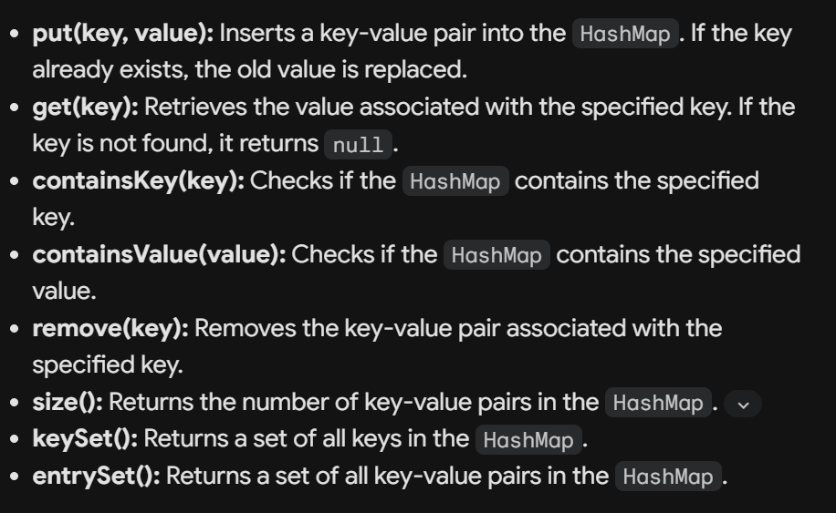
- Key Characteristics:
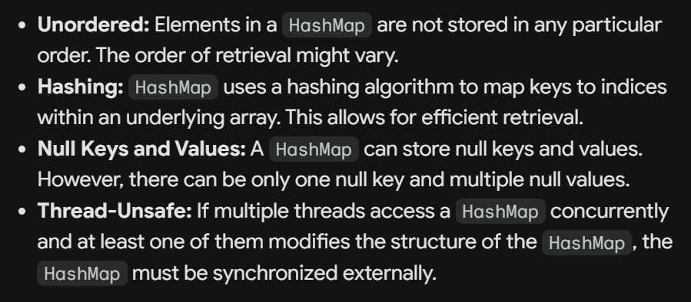
- More important points:
